Week in Review - March 9-March 15
Alex Shvartsman

GRAND PRIX: RIO
Carlos Romao and Rafael Le Saux both who finished in the top 8 of the previous Grand Prix held in Brasil - GP Sao Paulo. In that tournament Le Saux defeated Romao in the round of 8. This time around, Romao went all the way.
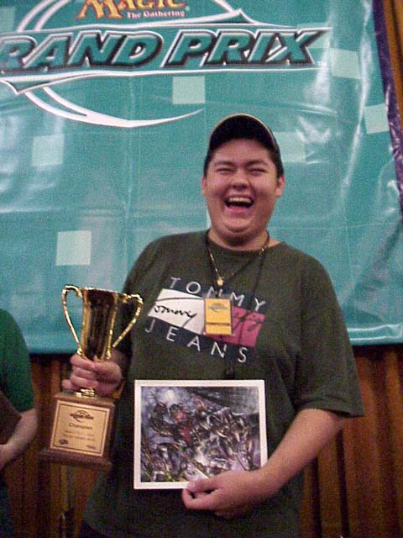
Carlos Romao, Grand Prix Rio Champion
Romao defeated me in the finals, but I cannot really complain at all about my finish. I come off a three month long slump - this is the first major tournament I did well in since a very successful weekend at PT Chicago. My self-set goal was to enter PT Tokyo with at least 19 PT points this season (after exactly half of the season, that would give me half the points potentially needed to remain qualified for the Masters Series next year). The last two Grand Prix I attended yielded me no points at all, but a strong finish in Rio has me back on track, and looking forward to competing in Tokyo this weekend. I also secured my Grand Prix Top 8 record (11 total now) for at least a while longer - Steve OMS was ready to catch up, at 9 GP top 8's.
In the third place was another American, Justin Schneider. Schneider did well on the Junior Pro Tour several years back, and has just recently returned to playing Magic after a two year long hiatus. Justin actually credited Sideboard for playing a role in bringing him back into the game. "I was bored one weekend, and went online, and started reading tournament coverage. Results, feature matches . . . it got me excited about the game again, made me want to compete." Justin re-familiarized himself with the cards and recently attended Grand Prix: Boston, where he finished in top 64, but out of the money. Rio had gone well for him - Schneider remained on top of the standings throughout most of the tournament, entering the top 8 as the #1 seed. He also drafted the best deck in the top 8, but Romao took him down all the same, to the wild cheers of the spectators.
The spectators were actively rooting for the local players to defeat the North American pros. Although hearing a deafening roar when your opponent beats you is not necessarily pleasant, I must say that I truly respect their enthusiasm. It is incomparable to North American Grand Prix, where there are often only a handful of spectators bothering to watch the finals, let alone the feature matches.
Despite the crowd's wishes, US players did very well overall - with David Williams missing the Top 8 on tiebreakers, and Steve OMS posting a strong Top 16 finish. Jose Cintra was the fifth American to finish in the money, in 22nd place.

GRAND PRIX: PRAGUE
Ryan Fuller took the top prize in Prague defeating Swedish player Jens Thoren, and now every member of team AlphaBetaUnlimited can boast a Grand Prix win this season. Teammate Noah Boeken also made Top 8. European Grand Prix Top 8's are beginning to look very repetitive - with Fuller, Boeken, Ruel brothers and a handful of other players appearing in most of them. This tournament was no exception, with Antoine Ruel right there in the Top 8.

Ryan Fuller, Grand Prix Prague Champion
Other notables included the recently European Trey Van Cleave, PT London finalist Thomas Preyer, and top local player and a one time World Champion Jakub Slemr.
I do not have a lot of details about this tournament, since I was at Rio instead, and am writing this on the plane to Tokyo. One story told at the tournament however was so interesting , my editors made sure I heard about it. Instead of trying to recap it for you, just go ahead and read it for yourself, here.

COMING UP: TOKYO MASTERS SERIES
The third Masters tournament will not have thirty two players compete for the prize. Instead, a total of twenty four players - or eight teams - will fight it out over the course of the weekend.
Enough has been written about the qualified teams. More will come during the coverage later this week. Instead, I would like to preview some of the pro teams that will be competing in the single elimination Gateway tournament, for that coveted eighth spot.
Wizards of the Coast made it pretty difficult for an average Pro to compete in this particular tournament. "We did not want mercenary teams showing up," explained one official. Thus, it is not possible to qualify for the gateway on the strength of the team's sum of Pro Tour points, as was possible for the Team Pro Tour. Only those teams with a DCI team rating of 1750 or higher will be allowed to compete, ensuring that only those teams that have played together for a while, or had a particularly high tournament finish, may enter the Gateway. As a result, few Pro teams will be able to play. Here is a list of a few that will very likely show up:
Dan Clegg, Thomas Keller, Shawn Keller
This team was qualified for the Masters itself - until an appeal filed by the Japanese team Panzer Hunters went through, posting them just a few DCI points ahead of the San Francisco team. To make up for withdrawing the invite, DCI offered the three players all-expense paid trips to Tokyo, and a chance to compete in the Pro Tour. Since they are going to be there anyway, they are extremely likely to play in the Gateway.
This team earned its rating by finishing in the top 4 of the team Pro Tour earlier this season. All three of the other top 4 finishing teams are qualified and will compete in the Masters. Shawn Keller and Clegg have played together since the first Team Pro Tour. Shawn's brother Thomas replaces Alec Hsu as their third teammate.
Jon Finkel, Steve OMS, Dan OMS
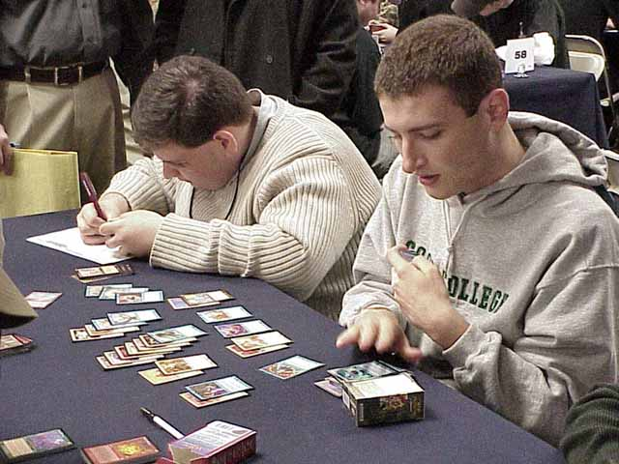
Team Antarctica
Team Antarctica is a true powerhouse in the format, and has also been together since its conception at PT Washington D.C. There have been some rumors of Finkel leaving the team to play with Bob Maher at the next team Pro Tour. Whether or not this is true, they are planning to play in the Gateway together, having missed the Masters invite by just a few DCI ratings points.
Trevor Blackwell, Nick Wong, Alex Shvartsman
This team played together exactly once - at Grand Prix: Nagoya, where we became the first players from outside Japan to win a Grand Prix held on that island. That was good enough to earn us a rating of 15th in the world - but with me in New York, Trevor in California, and Nick in Singapore - there was no chance for us to play in a few more tournaments together to try and qualify for the Masters in that fashion. Instead, the team will reunite on Thursday morning and attempt to win the Gateway despite lack of preparation. Who knows, perhaps we will get a little lucky - we have Nick's famous Lucky Duck after all.
Erno Ekebom, Tommi Hovi, ?
Erno was kind enough to e-mail me about his team, but that information is sitting on my hard drive, a few thousand miles away from here. I would like to apologize to him and his teammate, whose name I do not remember. It is hard to forget Ekebom and Hovi though - easily the best players in Finland. Hovi is one of only three players to win two Pro Tours. Ekebom has a couple of Pro Tour top 8 finishes, most recent one being in Los Angeles several weeks ago. This team most likely did practice and should have a good shot at doing well.
Ryan Fuller, Noah Boeken, Chris Benafel
Team AlphaBetaUnlimited has been riding the Grand Prix circuit very successfully this season. With Fuller's win in Prague, each of them has a GP win, and they share about a dozen top 8 finishes for the season. How well will this team fare at the Gateway? It's difficult to say, but they certainly have a shot if anyone does.
Overall, organizers expect about twenty teams total, most being from Japan. The Gateway will be an excellent chance for all of us to dust off the Team Limited skills in preparation for the next Grand Prix season.

COMING UP: PT TOKYO
Much has been posted over the last few months about what IBC is really like. None of it however, has been written by players who will actually be competing in Tokyo. So you've heard it here first - a preview of what the Tokyo metagame will really be like (based purely on my testing. But then if I am wrong, humbling myself in print won't be as bad as getting smashed in Tokyo anyway).
The most popular decks, in order of occurance, are likely to be:
Black-Red-Blue
This color combination has all the best toys. Fact or Fiction, Ghitu Fire, Void, Yawgmoths Agenda are some of the most powerful cards in the format - and this deck can play all of them without really hurting its mana base much. The versions of BUR I've seen vary mostly in exactly how they go about killing the opponent. Some of the better versions have no creatures at all - they gain control of the board situation and eventually cast several Ghitu Fires or Urza's Rages for the win (Agenda helps). Pyre Zombie, Phyrexian Scuta, and even Crosis the Purger are among the creatures that get considered as alternative kill mechanisms. Almost every version of the deck that is willing to play creatures at all, will use the Nightscape Familiar. In addition to being a decent creature control card, Familiar makes almost every single spell in the deck cheaper. Nightscape Familiar will certainly be one of the most commonly played creatures in Tokyo overall.
Black-Red
The strongest two-color combination, it gives up on cool stuff like Fact or Fiction, Repulse, and Exclude. In exhange, it is able to set up a Pyre Zombie engine more consistently because of its mana and has a slightly better early game. Unlike BUR, this deck will play at least 12+ creatures. Versions vary from pure beatdown to discard, with discard versions performing a lot better in our testing. Blazing Specter, Skizzik, Pyre Zombie, Phyrexian Scuta, Nightscape Familiar, Ravenous Rats, Flametongue Kavu are all solid creatures for this archetype.
Red-Green
This is the Sligh of the format. It's all about two casting cost creatures like Yavimaya Barbarian, Kavu Titan, even Blurred Mongoose if that's the kind of metagame you are expecting. Early damage backed up with Rage and Ghitu Fire is a combination that can stand up to virtually anything else in the format. I will go as far as to say this is probably the best Game 1 deck the format has. However, the decks listed above will crush it after sideboard if they want to. Slay, Flametongue Kavu and Exclude are cards Red-Green may be able to handle a few of at a time, but overloading the deck with them after sideboarding will leave any BUR mage at a considerable advantage.
Domain
The most interesting deck to come out of this format, "Domain" stands for the 5-color strategy built into cards like Allied Strategies, Tribal Flames, and Worldly Counsel. This deck uses green mana fixers like Harrow and Elfhame Sanctuary to get all five basic land types into play, then casts Collective Restraint to slow an opponent down, and Global Ruin to make sure they do not get to attack you ever again. At that point the deck has a number of cards it can potentially win with - Ordered Migration, Exotic Disease, and Tribal Flames being the most popular. Dragon Legends and other various giant monsters are an attractive alternative that some players are using, but keeping the deck creatureless is too attractive an opportunity to pass up in this format, where creature kill plays such an important role.
Slightly less popular but certainly felt will be B/U and G/W decks. I do not expect to see a lot of U/W, nor many mono-color decks - though mono red is potentially viable.
After PT Tokyo, I will be working on a series of articles discussing the above archetypes in detail.

MAGIC TRIVIA.
Last week's questions:
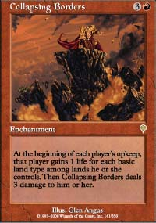
What is the only red card that allows it's caster to gain life?
There are actually several, though I could only think of one at the time someone suggested this question. The card I had in mind is Collapsing Borders. Other options include Thunderscape Battlemage and Game of Chaos. There are surely more, but these are the answers I can think of at the moment.
What is the only card to feature an actual historical figure in its artwork?
This one does have only one answer. It is the Legends version of Presence of the Master. Its artwork depicts Albert Einstein, a brilliant scientist who came up with the Theory of Relativity.
This week's question:
What other Legends' card makes a reference to Einstein in its artwork?
Please do not e-mail me your answers. There is no prize, this is strictly for fun. Correct answer will be posted in the next week's column.

YOUR MANA'S WORTH
These two important rulings that will come up often in your Invasion Limited games:
Do Familiars reduce the Kicker cost?
Yes. Familiars are worded to reduce "play cost" of a card, which includes kicker. Thus, with a Thunderscape Familiar in play, you can summon a kicked Duskwalker for BB2. However, Familiars do not reduce BOTH kicker and actual cost. With Nightscape Familiar in play, Urza's Rage for ten will still cost you 11, not 10 mana.
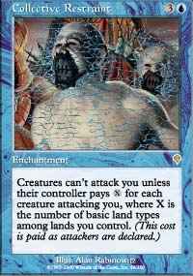
With Collective Restraint in play, can I tap an opponent's creature after he pays the mana?
Nope. By the time the mana is paid, you've already passed the opportunity to use your Benalish Trapper or Apprentice.

BAD PLAY OF THE WEEK
Robert Lloyd from London reports a following play he observed while watching a match at a local PTQ.
In the middle of the game, one of the player got an advantage, having Sunscape Apprentice and a Kavu Climber in play while his opponent had nothing but lands. Instead of attacking for four points per turn, that player elected to 'gain card advantage' by putting his Climber on top of the library every turn, then casting it. Apparently he failed to grasp that by sending a card onto the top of his library, he negated any card advantage and was actually drawing the same one card per turn he normally would - with an added disadvantage of keeping his two creatures busy and spending six mana each turn!
As always, please send good/bad plays, cool trivia questions, and other news to ashv@concentric.net
I would like to apologize to everyone in advance, but I won't be able to reply to any e-mail until March 19 because of an extended trip. If you e-mail me, please expect a reply after that date.

